跨越界限，携手共进
——Opening Ceremony for MUNUC-SFLS 2024
"Hand in Hand for a Shared Future"
——记上外附中﹣芝加哥大学国际模拟联合国大会会议开幕式

At 4:00pm, December 19th, the opening ceremony of the “MUNUC-SFLS 2024” Model United Nations Conference was held at the art hall of SFLS.
12月19日下午，上海外国语大学附属外国语学校-芝加哥大学国际模拟联合国大会开幕式在上外附中艺术中心隆重举行。

Principal of Shanghai Foreign Language School Mr. Du Yuehua, Vice Principal Mrs. Hang Hongli, Deputy Party Secretary of Shanghai Foreign Language School Mrs. Lin Jiong, Vice Principal Mrs. Yue Lan and school officials attended the ceremony. In the meantime, the Secretary General from the University of Chicago Hing Yee Choy, Director General Kaitlin Albarran, CEO of WELAND International Mr. Cao Shuye, the DAIS and student secretariat members were present at the opening ceremony. In addition, over 500 delegates coming from all over China have participated in this ceremony.
出席本次开幕式的校领导有校长杜越华，副校长杭虹利，副书记林炯，副校长岳岚等；到场的来宾还有MUNUC-SFLS 2023模拟联合国大会秘书长Hing Yee Choy, 主席团指导Kaitlin Albarran，蔚蓝国际首席执行官曹疏野，以及芝加哥大学主席团。此外，来自全国各地的500余名代表见证了这一重要活动的开幕。

Student MCs Jiang Ruicheng and Zhang Renyuan expressed great enthusiasm and most sincere welcome to delegates and chairs that have come a long way for this grand event.
学生主持人蒋睿铖与张任圆对远道而来的代表和主席们表示了极大的热情和诚挚的欢迎。

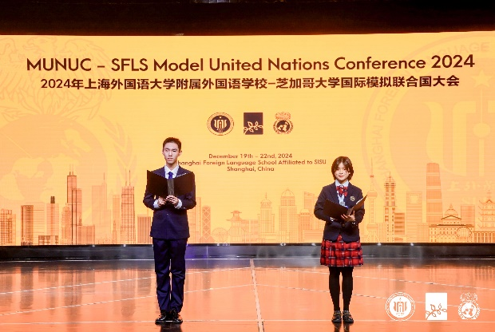

Principal of SFLS, Mr. Du Yuehua made his opening address. Fang Zhuoying, a member of the SFLS Main Press Center interpreted for this address. Mr. Du extended a warm welcome to all the guests and delegates present. He emphasized that MUN is not only an academic exchange but also an important platform for cultivating leadership. He encouraged the delegates to demonstrate their leadership skills, teamwork, innovative solutions, and active cooperation to address global issues.
Finally, Mr. Du looked forward to the growth and inspiration that the delegates would gain during the next four days and wished the conference a success.

上外附中校长杜越华致辞，上外附中媒体团成员方焯樱担任英语翻译。杜校长向与会的各位嘉宾和代表们表示热烈的欢迎。回顾人类推动全球和平与发展的伟大历程，杜校长表示，模拟联合国会议是悠久的历史传统的延续。他强调，模拟联合国不仅是一次学术交流，更是培养领导力的重要平台。他鼓励与会代表们在大会中展现自己的领导才能与团队协作精神，创新解决方案并积极合作，推动全球问题的解决。最后，杜校长衷心祝愿本次大会圆满成功，并期待各位代表在未来四天中收获成长与启发，为全球和平与人类福祉贡献智慧与力量。

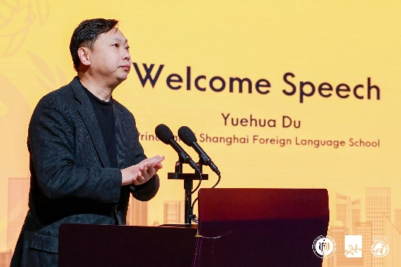

Following, Secretary General Hing Yee (Cissy) Choy delivered her keynote speech. Cissy's MUN journey began in Shanghai, where she debated water sanitation in one of the committees. MUN is an incredible, versatile community that offers something unique to everyone, she said—whether it's winning, succeeding, or grappling with frustration. Ultimately, she expressed, MUN teaches you how to care about the world, the people around you, and yourself. MUN emphasizes valuing your voice and perspective and discovering the transformative power of leadership. Before concluding, Cissy introduced the MUNUC directors, expressing her gratitude for their invaluable contributions to the conference.

接下来，秘书长Hing Yee（Cissy）Choy发表了主题演讲。Cissy的模拟联合国之旅始于上海一个执行会议室中关于水资源问题的辩论。她表示，模联活动是一个极其多元化的社区，它致力于为每个人提供独特的体验——无论是取得成功，亦或是面对挫折与挑战，模拟联合国最终教会你如何关心这个世界、关心身边的人以及关心自己。她表示，模联注重思考与表达，并运用领导力推动世界发展与变化。在演讲的最后，Cissy介绍了各会场的主席，并对他们为大会作出的宝贵贡献表示由衷的感谢。

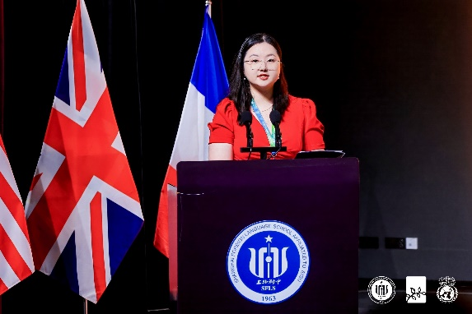

The Secretary-General of the students, Zhang Haoqing, expressed in his speech that the world needs the voices of youth more than ever. He particularly thanked and praised the hard work of the organizing team. He mentioned that MUN is not only a platform for debate but also an opportunity to promote understanding, inclusion, and cooperation. He encouraged the delegates to actively participate in discussions, address global challenges, and demonstrate leadership and innovative thinking to contribute to global peace and cooperation.

学生秘书长张皓清致辞。他特别感谢了大会筹备团队的辛勤付出。他表示，世界比以往更需要青年的声音。模拟联合国不仅是辩论的平台，更是促进理解、包容和合作的机会。秘书长鼓励与会代表积极参与讨论，解决全球挑战，展现领导力和创新思维，为推动全球和平与合作贡献力量。他祝愿大会圆满成功，期待代表们在接下来的日子里展示才华、达成共识、收获成长。

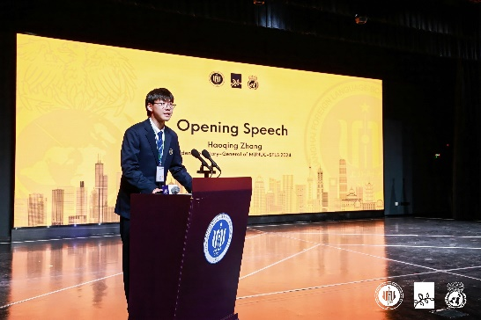

Afterwards, Principal Mr. Du, Secretary General Ms. Choy, WELAND International CEO Mr. Cao, and Student Secretary General Zhang Haoqing jointly declared the opening of this conference.
随后，杜越华校长，秘书长Choy女士，蔚蓝国际首席执行官曹疏野先生与学生秘书长张皓清宣布本次大会开幕。

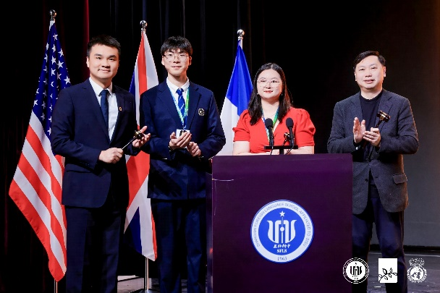

Ambassador Zhang Jianguo delivered the opening remark for this conference. Ambassador Zhang expressed his gratitude for the invitation from the organizing committee and extended his warm congratulations on the successful opening of the conference. He stated that, as a diplomat, he was deeply moved to see young people care about their country and pay attention to current affairs. Ambassador Zhang reminisced about his childhood and shared his reflections on his diplomatic career. He emphasized that telling China’s story well is crucial, regardless of the position one holds. During his tenure as Ambassador to Tunisia and Mauritania, he felt the weight of the responsibility that comes with diplomacy. He particularly recalled the moment when he personally handed over pandemic relief supplies at the international airport in Nouakchott, the capital of Mauritania, and felt an immense sense of pride, knowing he had the strong backing of his country. He stressed that diplomacy is a noble and sacred cause, and he is proud of the remarkable achievements of China's all-encompassing diplomatic strategy and the Belt and Road Initiative. Diplomacy requires a balance of principles and flexibility, while also fostering professional knowledge, communication skills, and insight to firmly defend the interests and dignity of the country and its people, resolve conflicts, and reach a consensus.

张建国大使为本次会议作主旨演讲。张大使对组委会的邀请表示感谢，并对大会的顺利召开表示热烈祝贺。他表示，作为外交官，看到青少年关心国家、关注时事，深感欣慰。张大使回忆起童年时的经历，分享了自己从事外交工作的感悟。他提到，讲好中国故事无论在哪个岗位都至关重要。在担任突尼斯和毛里塔尼亚大使期间，张大使深刻感受到外交工作的责任重大。特别是在毛里塔尼亚首都努瓦克肖特国际机场亲自交接抗疫物资时，他因背后有一个强大的祖国而感到无比自豪。他强调，外交事业崇高而神圣，外交工作需要在原则性和灵活性平衡的同时培养专业知识、沟通能力和洞察力，为国家利益坚定发声，化解矛盾，达成国际共识。

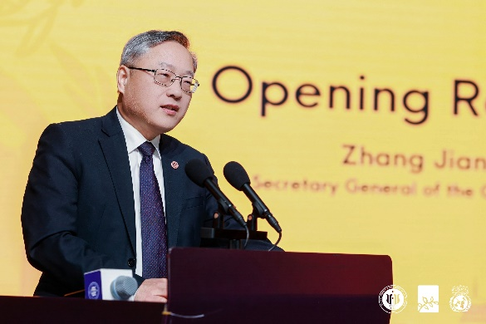

In the next 4 days, delegates will embark on their journey of discussion within 9 committees. We sincerely hope that all delegates can enjoy the conference, and that MUNUC-SFLS 2024 will be a memorable MUN experience for everyone.
在接下来的四天里，代表们将在九个委员会中围绕不同议题展开讨论。我们衷心希望本次模联大会能够为参与者们留下难忘的回忆和宝贵的经验。

Script | Zhihe Chen, Xiaohan Lin (Main Press Center)
撰稿 | 陈之訸 林小涵 (上外附中媒体团)

